1. **Find the boundary of the image using Convolution kernel for the given image**

**Aim:**

To find the boundary of the image using a convolution kernel for the given image.

**Code:**

import cv2

import numpy as np

import matplotlib.pyplot as plt

image = cv2.imread(r"C:\Users\prith\Documents\CV\cvimage.jpg", cv2.IMREAD_GRAYSCALE)

sobel_x = np.array([[-1, 0, 1],

[-2, 0, 2],

[-1, 0, 1]])

sobel_y = np.array([[-1, -2, -1],

[ 0, 0, 0],

[ 1, 2, 1]])

edges_x = cv2.filter2D(image, -1, sobel_x)

edges_y = cv2.filter2D(image, -1, sobel_y)

edges = cv2.magnitude(edges_x.astype(np.float32), edges_y.astype(np.float32))

edges = cv2.normalize(edges, None, 0, 255, cv2.NORM_MINMAX).astype(np.uint8)

plt.figure(figsize=(10, 5))

plt.subplot(1, 3, 1)

plt.title('Original Image')

plt.imshow(image, cmap='gray')

plt.subplot(1, 3, 2)

plt.title('Edges X')

plt.imshow(edges_x, cmap='gray')

plt.subplot(1, 3, 3)

plt.title('Edges Y')

plt.imshow(edges_y, cmap='gray')

plt.figure()

plt.title('Combined Edges')

plt.imshow(edges, cmap='gray')

plt.show()

**Input:**

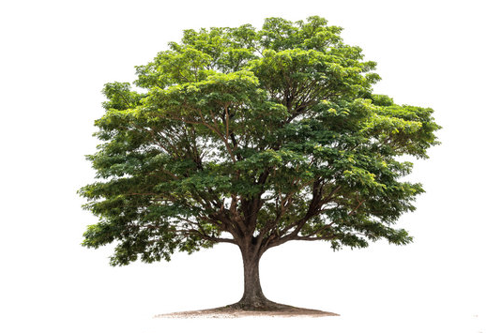

**Output:**

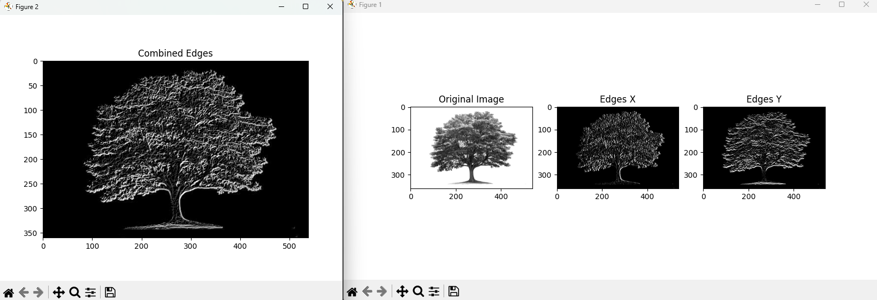

**Result:**

The python code to find the boundary of the image using a convolution kernel for the given image has been executed successfully.